Here are the steps I did to build the jQmobileFirst app.

Start new asp web app, choose empty

Turn off js debugging in VS (clear the box)

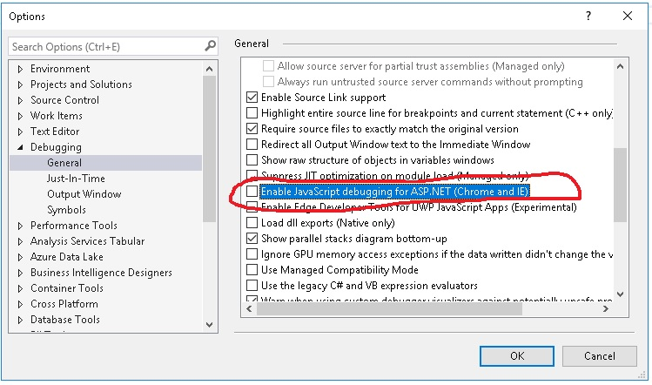

Add a Scripts folder and then add a new empty app.js javascript file

Add a css folder, in there add a themes folder, and then using file explore, add in the jquery.mobile.icons.min.css you extract from my themes.zip file. Then back in VS, you need to click on the themes folder, and “add existing”, and add that file.

Add an index.html file and pull in all the stuff we need:

<!DOCTYPE html>

<html>

<head>

<meta name="viewport" content="width = device-width, initial-scale = 1">

<title>Note App</title>

<script src="http://ajax.aspnetcdn.com/ajax/jQuery/jquery-2.0.3.min.js"></script>

<script type="text/javascript" src="Scripts/app.js"></script>

<link rel="stylesheet" href="https://code.jquery.com/mobile/1.4.5/jquery.mobile-1.4.5.min.css">

<link rel="stylesheet" href="css/themes/jquery.mobile.icons.min.css" />

<script src="https://code.jquery.com/mobile/1.4.5/jquery.mobile-1.4.5.min.js"></script>

</head>

Add the body content for 3 “pages”

<body>

<h2>1st jQuery Mobile</h2>

<div data-role="page" id="homepage">

<div data-role="header" data-theme="c">

<h3>First Page</h3>

<a href="#infopage" class="ui-btn-left" data-transition="flip">Get more information</a>

<a href="#detailpage" class="ui-btn-rigtht" data-transition="flip">Get the details</a>

</div>

<div data-role="content" data-theme="a">

<div>

Wonderfull welcome on the home page

<br /><br />

</div> <br />

</div>

<div data-role="footer" data-theme="c">

<h3>copyright Kurt Friedrich 2019</h3>

</div>

</div>

<div data-role="page" id="infopage">

<div data-role="header" data-theme="c">

<h3>Information Page</h3>

<a href="#homepage" class="ui-btn-left" data-transition="flip">Go back to Home page</a>

</div>

<div data-role="content" data-theme="b">

<div>

Wonderfull information on the information page

<br /><br />

</div> <br />

</div>

<div data-role="footer" data-theme="c">

<h3>copyright Kurt Friedrich 2019</h3>

</div>

</div>

<div data-role="page" id="detailpage">

<div data-role="header" data-theme="a">

<h3>Details Page</h3>

<a href="#homepage" class="ui-btn-left" data-transition="flip">Go back to Home page</a>

</div>

<div data-role="content" data-theme="c">

<div>

Wonderfull details on the details page

<br />

</div> <br />

</div>

<div data-role="footer" data-theme="a">

<h3>copyright Kurt Friedrich 2019</h3>

</div>

</div>

</body>

Make sure you have the closing

</html>